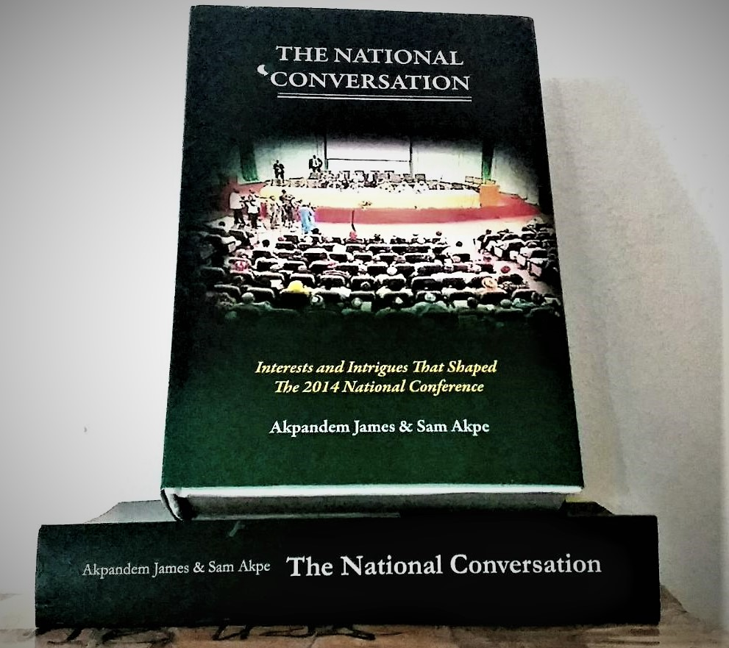
THE NATIONAL CONVERSATION
PRESS STATEMENT
PUBLIC PRESENTATION OF
THE NATIONAL CONVERSATION: INTERESTS AND INTRIGUES THAT SHAPED THE 2014 NATIONAL CONFERENCE
About eight years after the 2014 National Conference a thought came, that some of the issues that characterised the Conference, particularly the interests and intrigues that shaped the deliberations and outcomes, should be revisited. The idea was to look at the issues beyond what is already available to the public and what was published in the Main Conference Report.
That thought gave birth to a 633-page book titled The National Conversation: Interests and Intrigues that shaped the 2014 National Conference, written by two media professionals, Akpandem James and Sam Akpe, who were also at the Conference Secretariat.
The Conference was a fundamental step towards addressing weighty national issues that have been canvassed over the years by the different stakeholders in the country. Therefore, it was an important national project aimed at realistically examining and genuinely resolving long standing hurdles to national cohesion and inclusive development of the country.
This National Conversation distils some of the highlights of the Conference proceedings, the trajectory of events, including moves that led to some of the very critical decisions, major contributions by delegates, the contentions, as well as other issues that are not in the public domain.
Deputy Chairman of the Conference, Professor Bolaji Akinyemi, wrote the Foreword. The book will be presented to the public on Tuesday, June 28, 2022 by 10.00am at the Colonade Hall, NICON Luxury Hotel, near the CBN headquarters, in Abuja.
A review of the book will be done at the event by the Director, Institute of Legislative Studies and recently appointed Director, Abuja Leadership Centre, University of Abuja, Prof. Philip Afaha. Until recently, he was the Head of Department of History and Diplomatic Studies at the university.
The principal players in the birthing and nurturing of the Conference have given their word to be part of the event. Nigeria’s immediate past President, His Excellency Dr Goodluck Ebele Jonathan, GCFR, has accepted to be the chairman.
Former Secretary to Government of the Federation, Senator Anyim Pius Anyim, GCON, the INEC Chairman, Prof. Mahmood Yakubu; Conference Secretary, Dr Mrs Valerie Azinge; Dr Akilu Indabawa who was in charge of Conference Proceedings, delegates to the Conference, top politicians and journalists, business leaders, scholars and heads of development agencies, among others, have confirmed their availability for the event.
The book is done in three sections. Section One contains the build-up analysis, including the road to the Conference, why it was called and the overall agenda.
Section Two dwells on issues that shaped the Conference including how the Principal Officers handled the project; background to the composition of delegates and the contentious issue of representation; women at the conference - their antecedents and roles; how the Conference rules and procedures were fashioned out; the issue of voting and the 50 Wise men; the contentions that trailed the consensus groups; the ruckus over membership and leadership of Conference Committees; as well as wisecracks that tempered the ever rising tensions.
Section Three contains conversations and background moves that shaped decisions on critical governance issues like Devolution of Power and Resource Allocation; Politics and Governance; Political Parties and Electoral Matters; National Security; Religion; Immunity clause; State Police; State creation; the contentious Land Use Act; the issue of Cattle Routes and Grazing Reserves; revisiting Agriculture and Water Resources; and also delegates that can be described as the forerunners and the potentates before and at the Conference.
Apart from the front matters, the book has 105 pages of information on the structure of delegates by classification and by regions; Committees by responsibilities, leadership and membership; list of women and classification; those who died during the Conference, all the speeches delivered at both the inauguration and closing ceremonies; and a comprehensive indexing for easy reference. It is delivered in both hardcover and paperback.

Signed:
Akpandem James, fnge
Akpadem@yahoo.com
June 22, 2022

Partner: The Next Edition

